**MongoDB Lab Assignments -Day 1**

**MongoDB Exercise in mongo shell**

Connect to a running mongo instance, use a database named **mongo_practice**.

Document all your queries in a javascript file to use as a reference.

**Insert Documents**

Insert the following documents into a **movies** collection.

title : Fight Club

writer : Chuck Palahniuko

year : 1999

actors : [

Brad Pitt

Edward Norton

]

title : Pulp Fiction

writer : Quentin Tarantino

year : 1994

actors : [

John Travolta

Uma Thurman

]

title : Inglorious Basterds

writer : Quentin Tarantino

year : 2009

actors : [

Brad Pitt

Diane Kruger

Eli Roth

]

title : The Hobbit: An Unexpected Journey

writer : J.R.R. Tolkein

year : 2012

franchise : The Hobbit

title : The Hobbit: The Desolation of Smaug

writer : J.R.R. Tolkein

year : 2013

franchise : The Hobbit

title : The Hobbit: The Battle of the Five Armies

writer : J.R.R. Tolkein

year : 2012

franchise : The Hobbit

synopsis : Bilbo and Company are forced to engage in a war against an array of combatants and keep the Lonely Mountain from falling into the hands of a rising darkness.

title : Pee Wee Herman's Big Adventure

title : Avatar

Reference

https://www.tutorialspoint.com/mongodb/mongodb_insert_document.htm

**Query / Find Documents**

query the **movies** collection to

1. get all documents

db.movies.find()

1. get all documents with writer set to "Quentin Tarantino"

db.movies.find({writer : ‘Quentin Tarantino’})

1. get all documents where actors include "Brad Pitt"

db.movies.find({actors : ‘Brad Pitt’})

1. get all documents with franchise set to "The Hobbit"

db.movies.find({franchise : ‘The Hobbit’})

1. get all movies released in the 90s

db.movies.find({$and: [{year: {$gt: 1989}},{year: {$lt: 2000}}]})

1. get all movies released before the year 2000 or after 2010

db.movies.find({$or: [{year: {$lt: 2000}}, {year: {$gt: 2010}}]})

Reference: <https://www.tutorialspoint.com/mongodb/mongodb_query_document.htm>

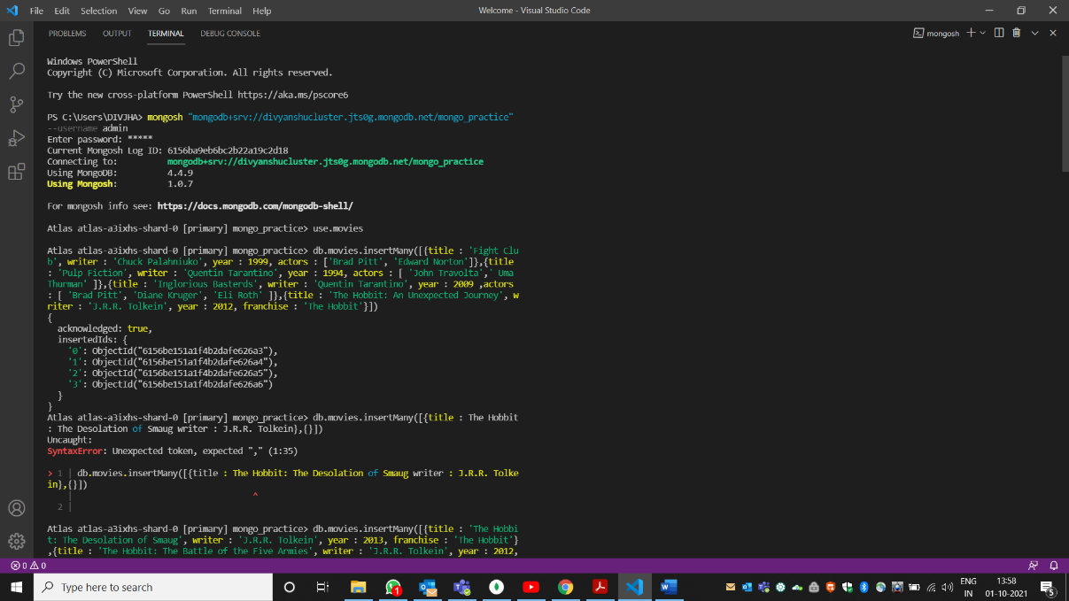

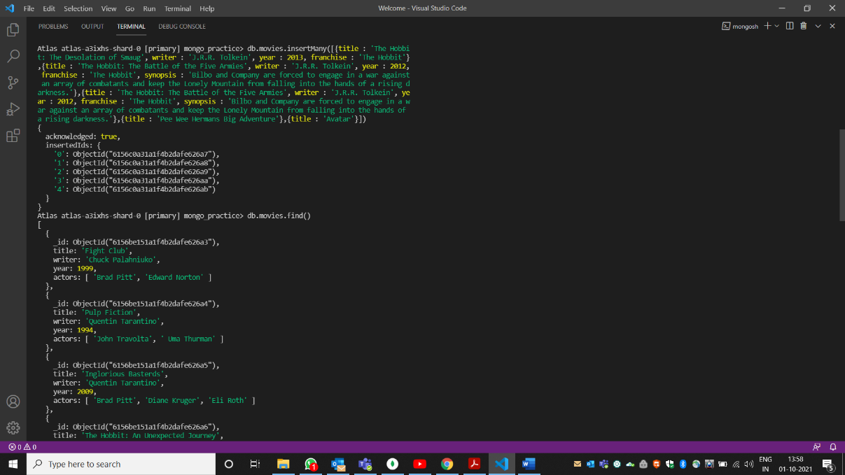

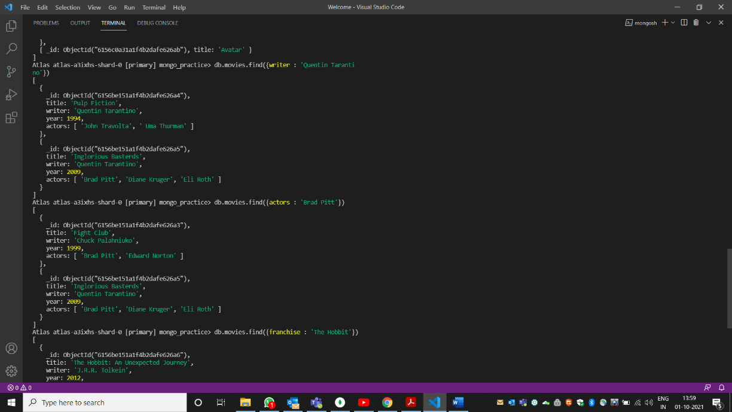

**Update Documents**

1. add a synopsis to "The Hobbit: An Unexpected Journey" : "A reluctant hobbit, Bilbo Baggins, sets out to the Lonely Mountain with a spirited group of dwarves to reclaim their mountain home - and the gold within it - from the dragon Smaug."

db.movies.update({title: 'The Hobbit: An Unexpected Journey'}, {$set: {synopsis: 'A reluctant hobbit, Bilbo Baggins, sets out to the Lonely Mountain with a spirited group of dwarves to reclaim their mountain home - and the gold within it - from the dragon Smaug.'}})

2. add a synopsis to "The Hobbit: The Desolation of Smaug" : "The dwarves, along with Bilbo Baggins and Gandalf the Grey, continue their quest to reclaim Erebor, their homeland, from Smaug. Bilbo Baggins is in possession of a mysterious and magical ring."

db.movies.update({title: "The Hobbit: The Desolation of Smaug"}, {$set: {synopsis: "The dwarves, along with Bilbo Baggins and Gandalf the Grey, continue their quest to reclaim Erebor, their homeland, from Smaug. Bilbo Baggins is in possession of a mysterious and magical ring."}})

3. add an actor named "Samuel L. Jackson" to the movie "Pulp Fiction"

db.movies.update({title: "Pulp Fiction"}, {$push: {actors: "Samuel L. Jackson"}})

Reference: <https://www.tutorialspoint.com/mongodb/mongodb_update_document.htm>

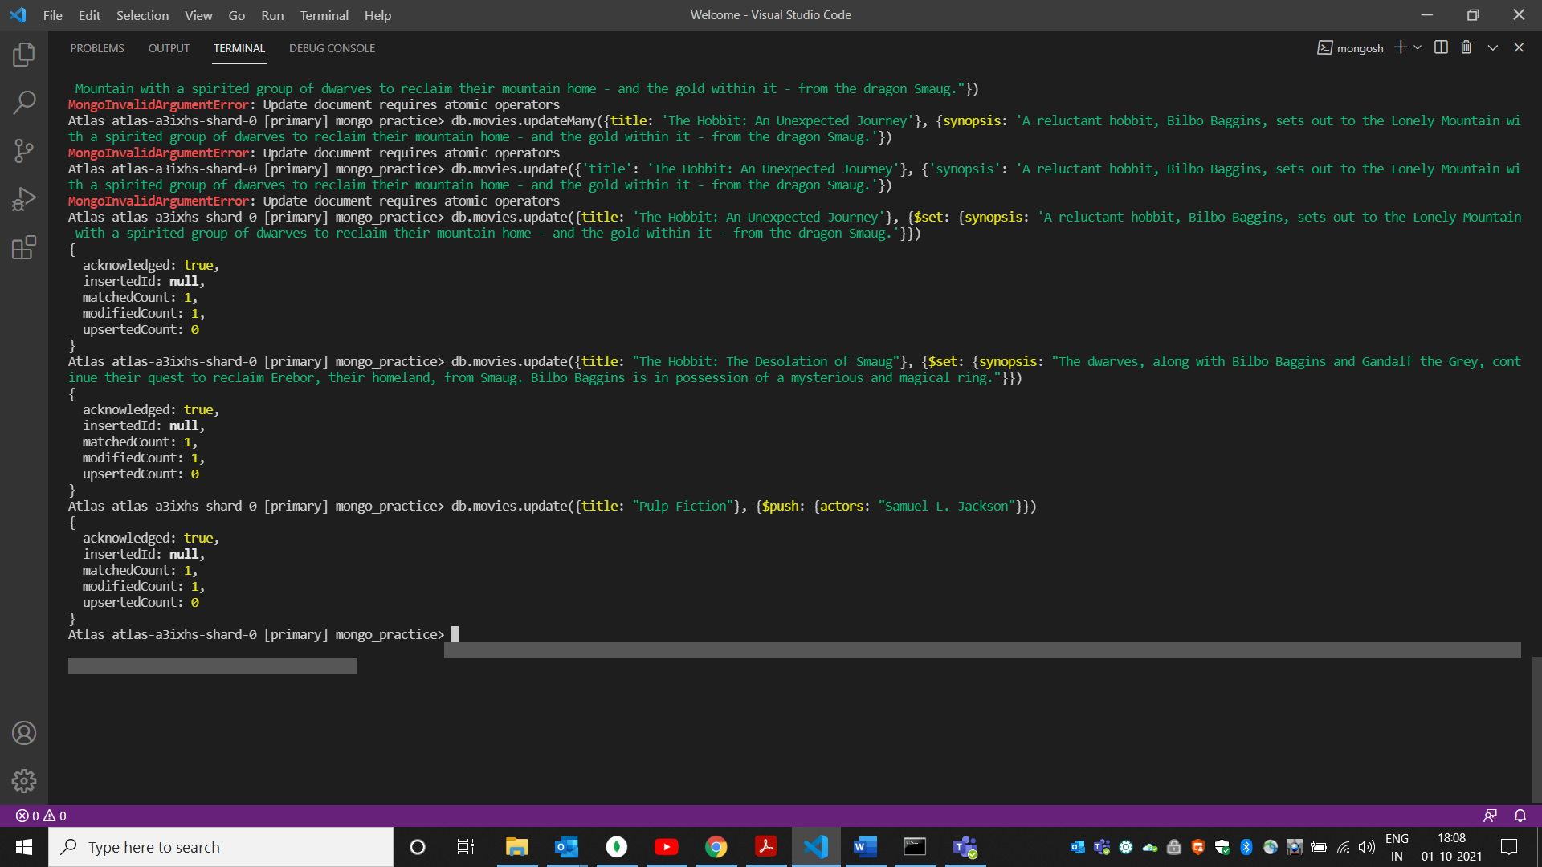

**Text Search**

1. find all movies that have a synopsis that contains the word "Bilbo"

db.movies.find({synopsis:{$regex:’Bilbo’}})

1. find all movies that have a synopsis that contains the word "Gandalf"

db.movies.find({synopsis:{$regex: ‘Gandalf’}})

1. find all movies that have a synopsis that contains the word "Bilbo" and not the word "Gandalf"

db.movies.find({$and: [{synopsis:{$regex:’Bilbo’}},{synopsis:{$not:/Gandalf/}}]})

1. find all movies that have a synopsis that contains the word "dwarves" or "hobbit"

db.movies.find({$or: [{synopsis: {$regex: ‘dwarves’}},{synopsis: {$regex’hobbit’}}]})

1. find all movies that have a synopsis that contains the word "gold" and "dragon"

db.movies.find({$and: [{synopsis: {$regex: ‘gold’}},{synopsis: {$regex’dragon’}}]})

Reference: https://www.tutorialspoint.com/mongodb/mongodb_text_search.htm

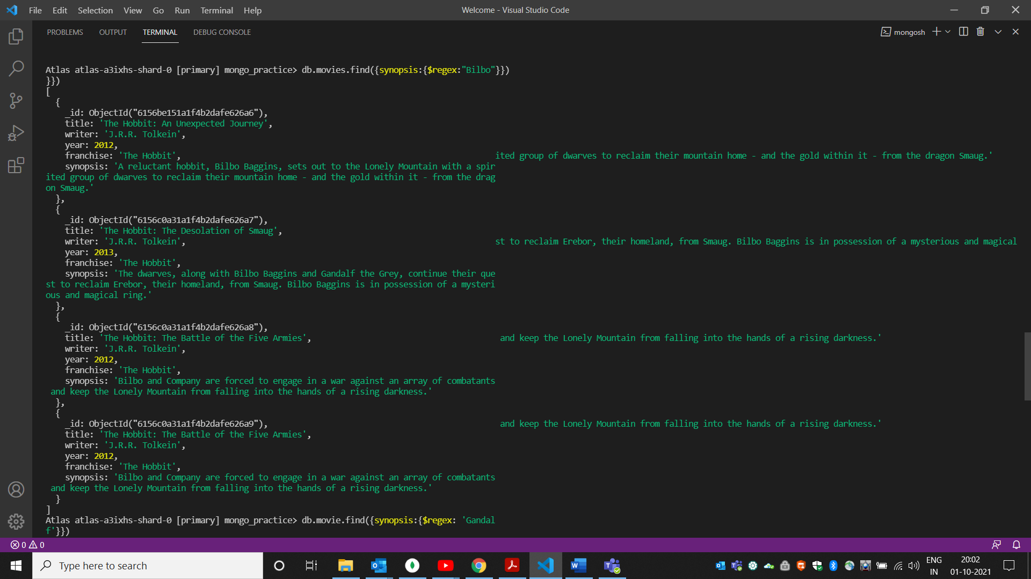

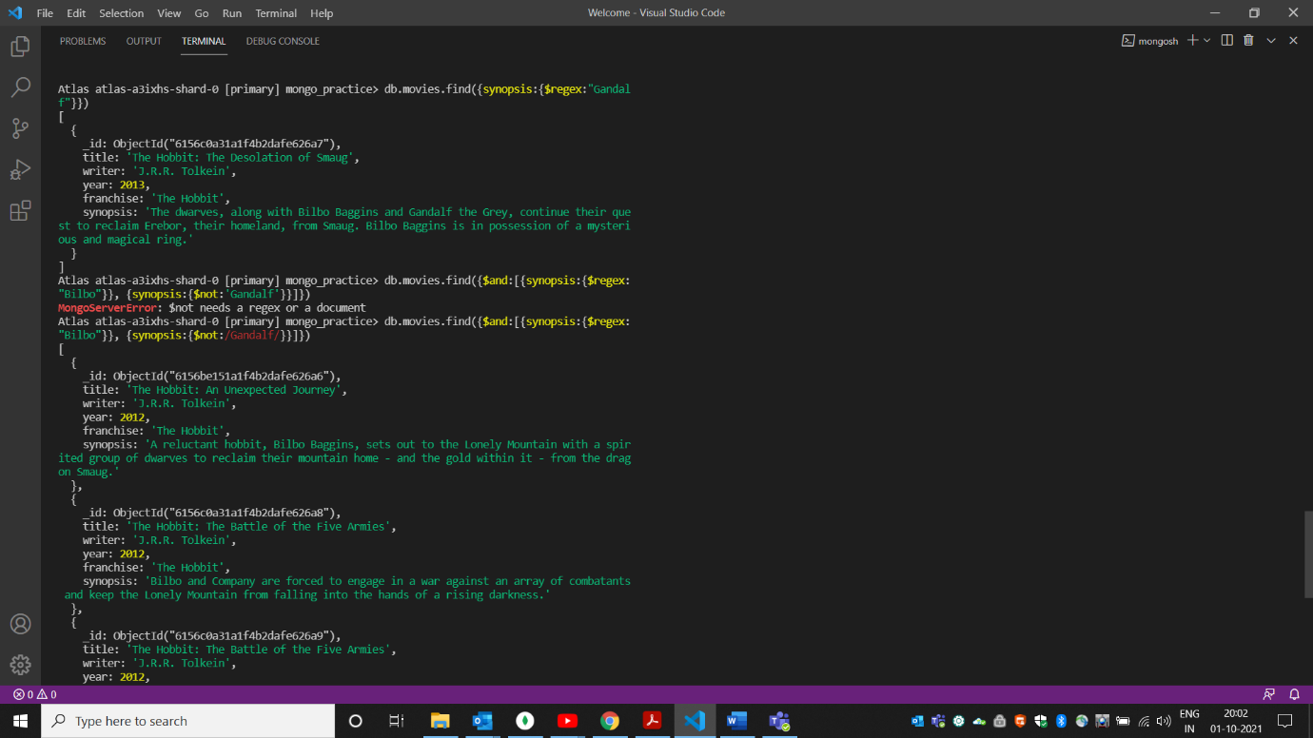

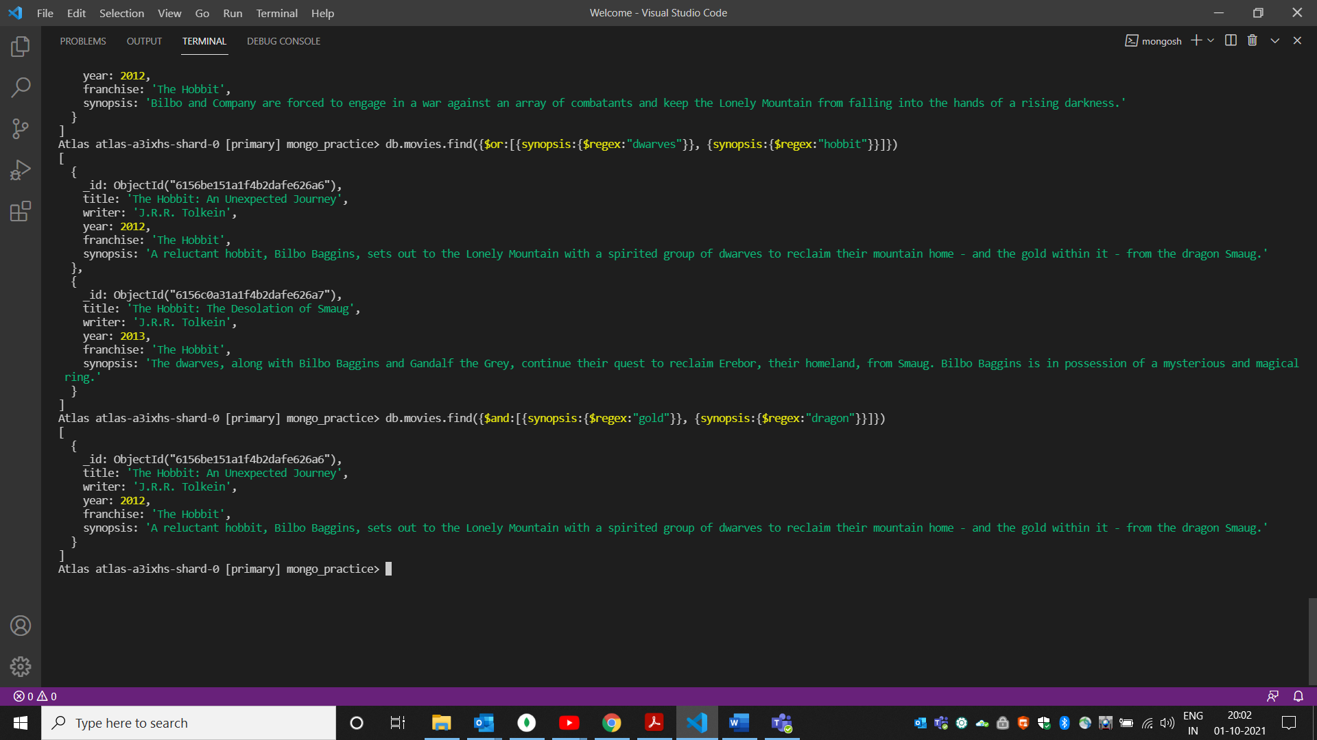

**Delete Documents**

1. delete the movie "Pee Wee Herman's Big Adventure"

db.movies.deleteOne({_id: ObjectId("6156c0a31a1f4b2dafe626aa")})

1. delete the movie "Avatar"

db.movies.remove({_id: ObjectId("6156c0a31a1f4b2dafe626ab")})

Reference: https://www.tutorialspoint.com/mongodb/mongodb_delete_document.htm

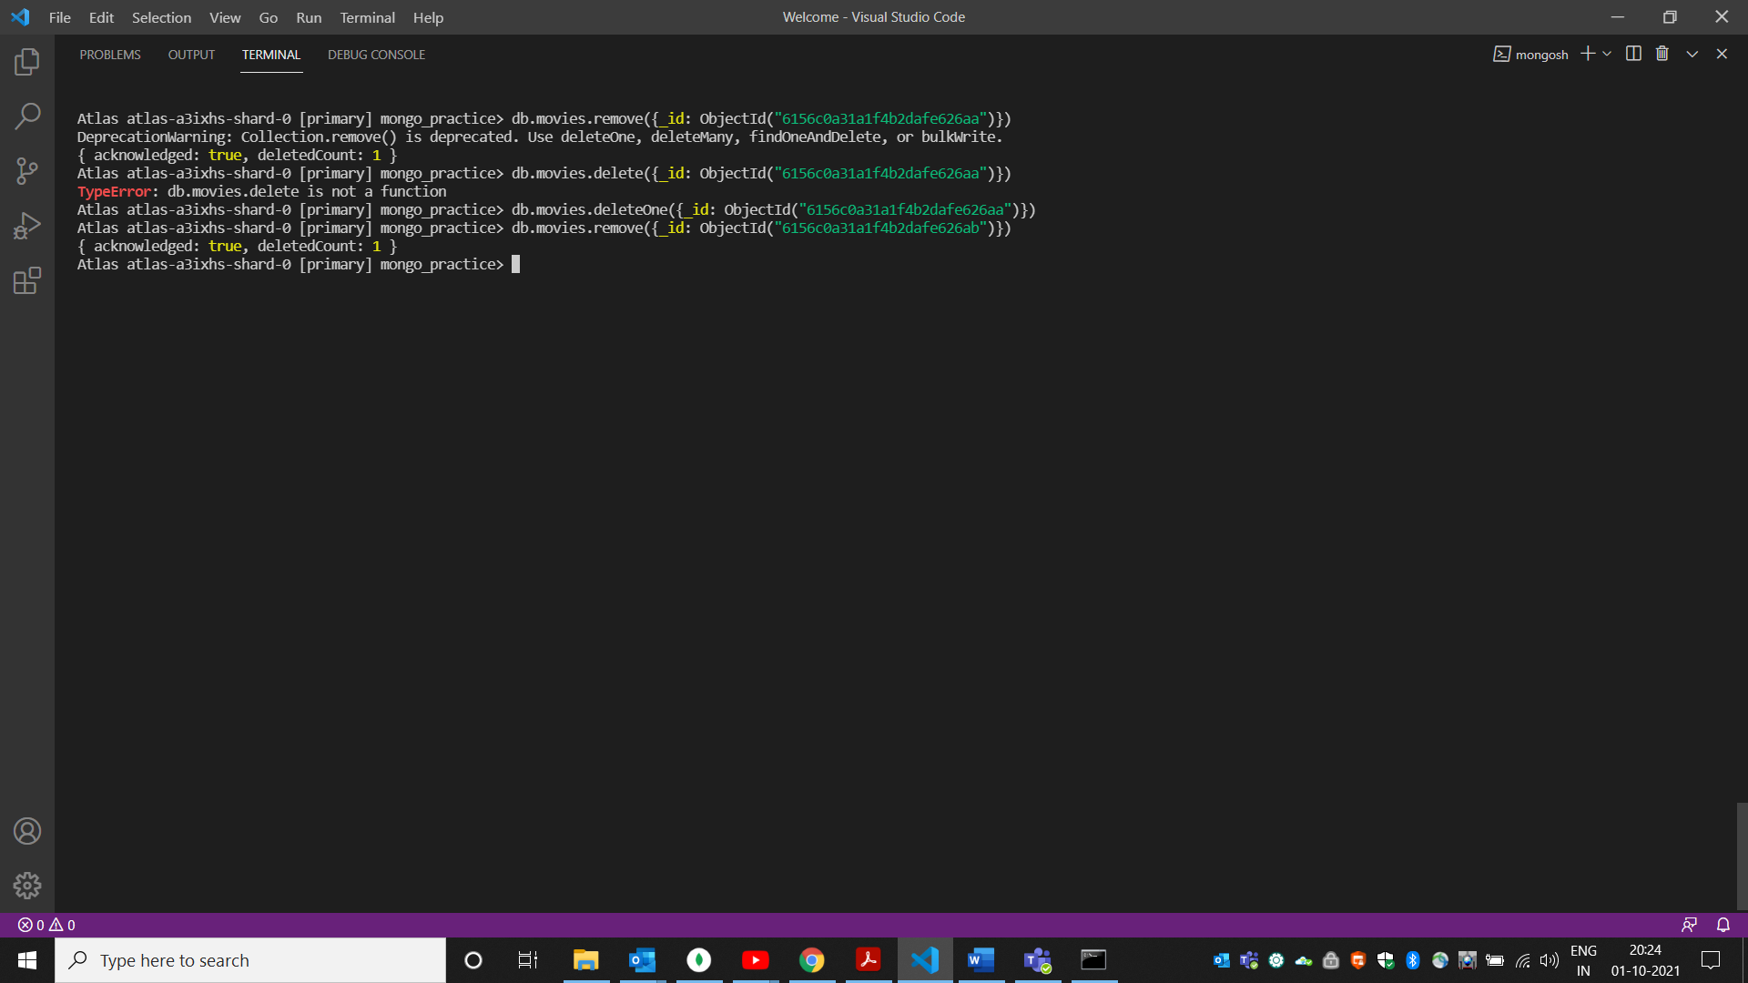

**Relationships**

Insert the following documents into a **users** collection

username : GoodGuyGreg

first_name : "Good Guy"

last_name : "Greg"

username : ScumbagSteve

full_name :

first : "Scumbag"

last : "Steve"

Insert the following documents into a **posts** collection

username : GoodGuyGreg

title : Passes out at party

body : Wakes up early and cleans house

username : GoodGuyGreg

title : Steals your identity

body : Raises your credit score

username : GoodGuyGreg

title : Reports a bug in your code

body : Sends you a Pull Request

username : ScumbagSteve

title : Borrows something

body : Sells it

username : ScumbagSteve

title : Borrows everything

body : The end

username : ScumbagSteve

title : Forks your repo on github

body : Sets to private

Insert the following documents into a **comments** collection

username : GoodGuyGreg

comment : Hope you got a good deal!

post : [post_obj_id]

where [post_obj_id] is the ObjectId of the posts document: "Borrows something"

username : GoodGuyGreg

comment : What's mine is yours!

post : [post_obj_id]

where [post_obj_id] is the ObjectId of the posts document: "Borrows everything"

username : GoodGuyGreg

comment : Don't violate the licensing agreement!

post : [post_obj_id]

where [post_obj_id] is the ObjectId of the posts document: "Forks your repo on github

username : ScumbagSteve

comment : It still isn't clean

post : [post_obj_id]

where [post_obj_id] is the ObjectId of the posts document: "Passes out at party" username : ScumbagSteve

comment : Denied your PR cause I found a hack

post : [post_obj_id]

where [post_obj_id] is the ObjectId of the posts document: "Reports a bug in your code"

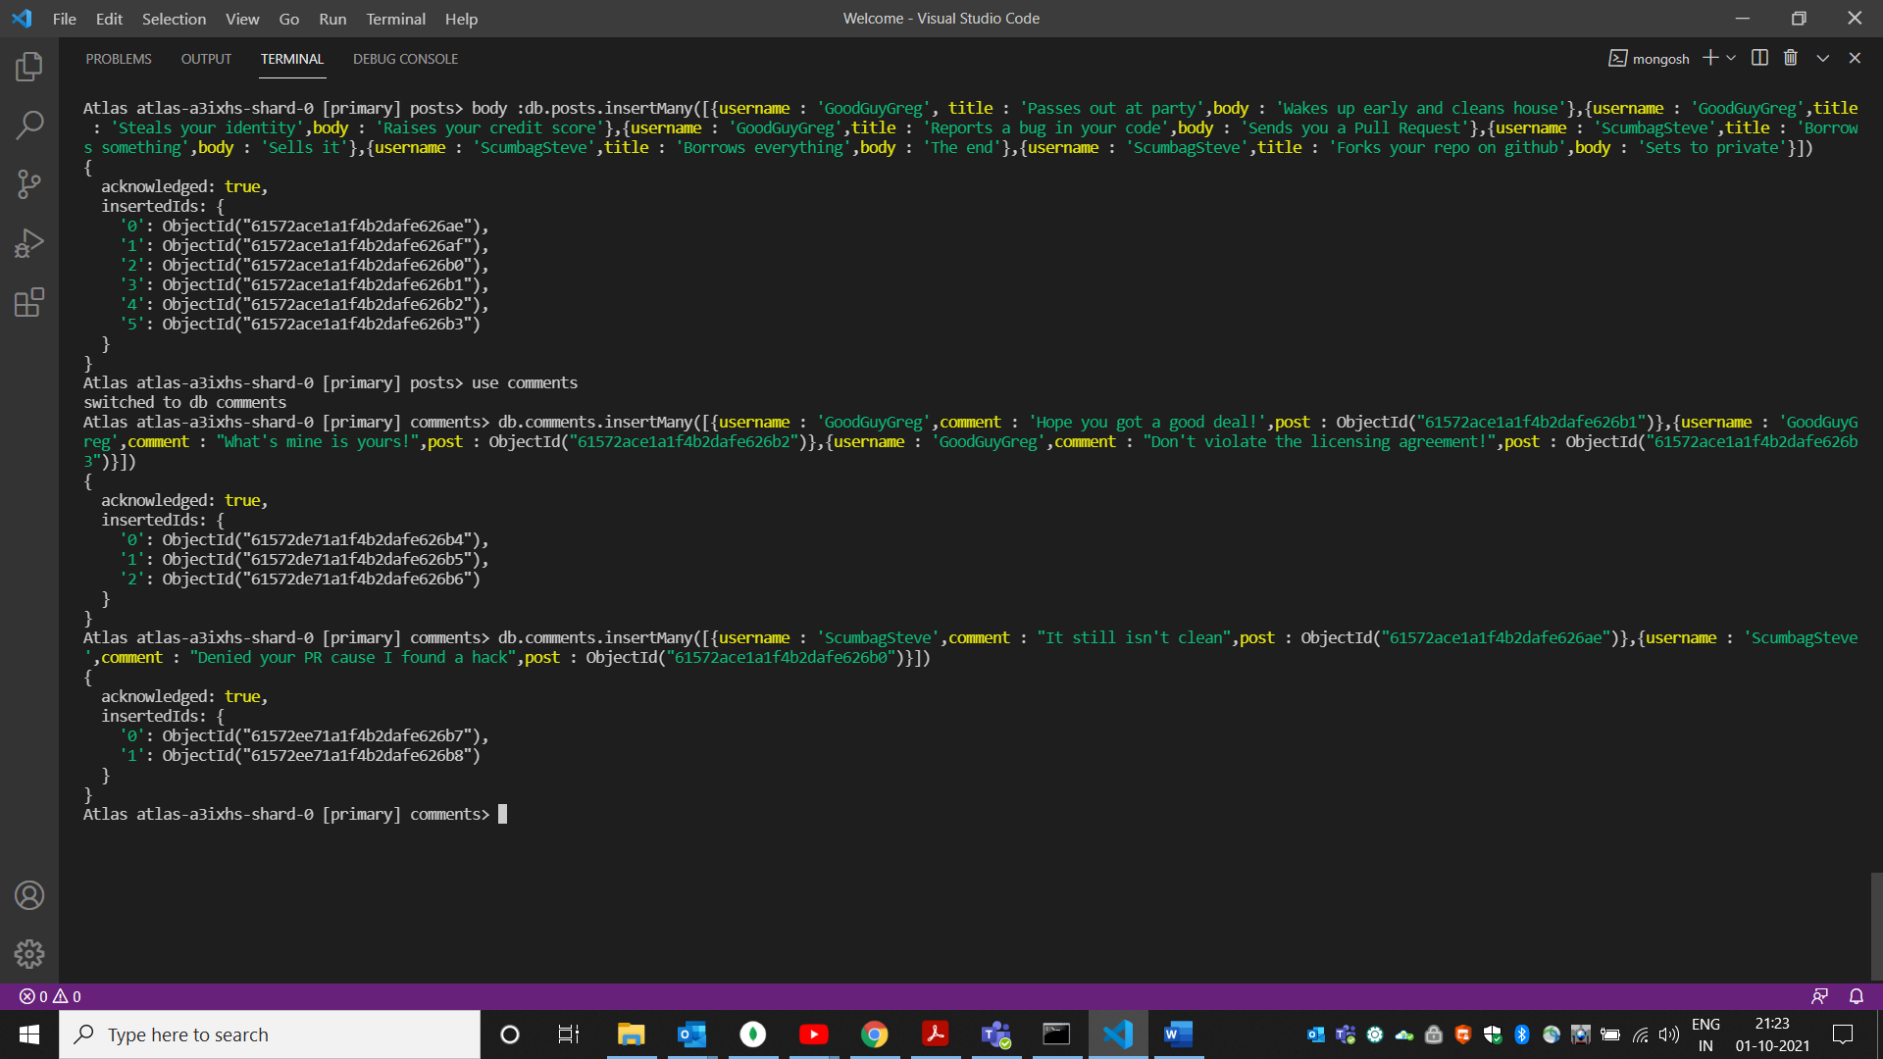

**Querying related collections**

1. find all users

use users

db.users.find()

1. find all posts

use posts

db.posts.find()

1. find all posts that was authored by "GoodGuyGreg"

db.posts.find({username:"GoodGuyGreg"})

1. find all posts that was authored by "ScumbagSteve"

db.posts.find({username:"ScumbagSteve"})

1. find all comments

use comments

db.comments.find()

1. find all comments that was authored by "GoodGuyGreg"

db.comments.find({username:"GoodGuyGreg"})

1. find all comments that was authored by "ScumbagSteve"

db.comments.find({username:"ScumbagSteve"})

1. find all comments belonging to the post "Reports a bug in your code"

References: <https://docs.mongodb.com/manual/reference/method/db.collection.find/>



